Stock bot report:

Stock I picked is called: SHOP (shopify inc)

I randomized it.

I also use TSLA,

Let me start with, this took way to long for just how simple it is.

I was too dumb to notice my mistake.

Calculating the RSI values shouldn’t take me too long, but me not knowing, I kept trying to fix the right code.

I’d say the hardest part is to make money from the algorithms.

One of the problem I encounter is when I tried to buy stock, for some reason it just buy out of pocket. I forgot to took a pic of the then current code, but I believe the part that was wrong is the tradeEvaluator():

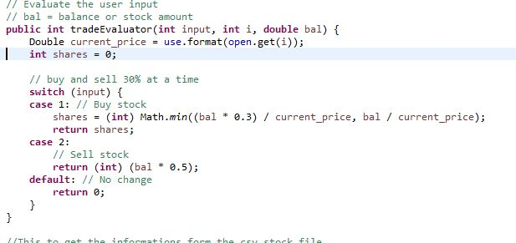

Three algorithms;

1. To buy and wait for a year.

I make it so that it shows waiting for 1-4 years

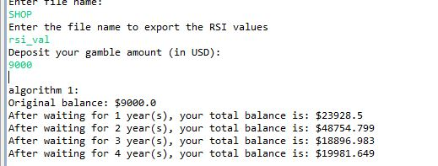

1. To using solely the RSI and MA to sell and buy.

I struggled with this one as well. Mainly because I don’t know exactly when to sell or buy. But in the end I make it to profit.

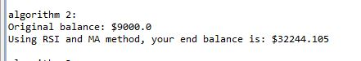

1. My algorithm nickname is “One-click-all”

I live and die with the stock, I went all in the first day and sell whenever the current price is higher than the buy price and the RSI value is above 70.

And I buy when the current price is less than the price that I originally bought the shares for, and that become my new buy price and the RSI value is above 30 and lower than 70.

I then tested this with Tesla:

This is where I fail kind of, I didn’t sell at the most efficient time.

Again with MTTR (Matterport inc)

